Name- Kaveri Avinash Jarhad
Shubhangi Balaji Khavle
Assignment No: 1
- Find the largest element in a list.
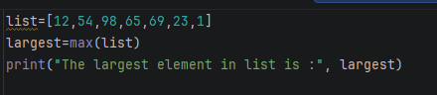
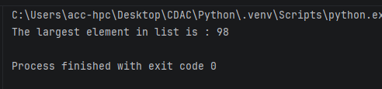
- Find the smallest element in a list.
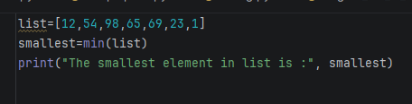
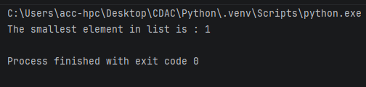
- Remove duplicates from a list.
v_list = [12, 2, 1, 2, 4, 2, 2, 3]
print("The original list is:", v_list)
uni_list = list(set(v_list))
print("The list after removing duplicates:", uni_list)

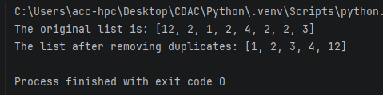
- Reverse a list.
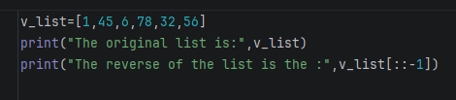
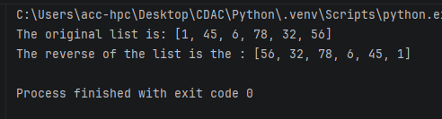
- Find the sum of all elements in a list.
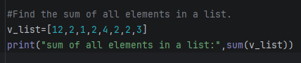
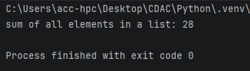
- Find the second largest number in a list.
v_list= [1, 22,54,85,2,48]
v_list.sort()
print("second largest number in a list",v_list[-2])

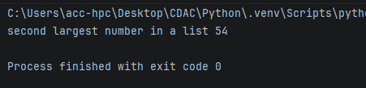
- Count how many times an element appears in a list.
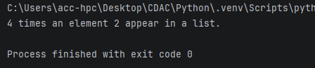
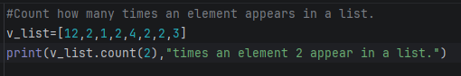
- Merge two lists into one.
list1 = [1, 2, 3, 4]
list2 = [5, 6, 7, 8]
list1.extend(list2)
print("After merging two list into one:", list1)

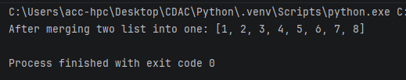
- Sort a list in ascending and descending order.
#Sort a list in ascending and descending order.
v_list= [1, 22,54,85,2,48]
print("The original list is:",v_list)
v_list.sort()
print("Ascending order:",v_list)
v_list.sort(reverse=True)
print("Descending order:",v_list)

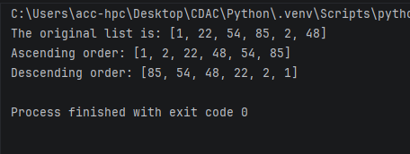

- Create a new list with squares of all elements
v_list = [1,2,3,6,8]
squares = [x ** 2 for x in v_list]
print("The original list is:", v_list)
print("The squares list is:", squares)

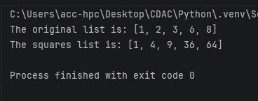

Assignment No: 2
Create a list of integers:
1. Find the sum of all elements
2. Find the maximum and minimum element
3. Sort the list in ascending order
#Find the sum of all elements
v_list=[12,2,1,2,4,2,2,3]
print("sum of all elements in a list:",sum(v_list))
largest=max(v_list)
print("The largest element in list is :", largest)
smallest=min(v_list)
print("The smallest element in list is :", smallest)
v_list.sort()
print("Ascending order:",v_list)

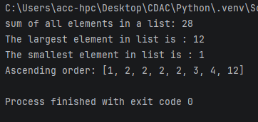

Write a program to remove duplicate elements from a list.
#Remove duplicates from a list.
v_list = [45,4,16,45,2,3,45]
print("The original list is:", v_list)
uni_list = list(set(v_list))
print("The list after removing duplicates:", uni_list)

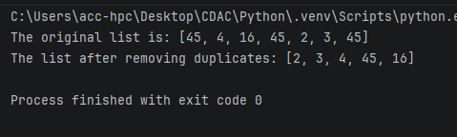

Create a tuple of numbers and:
1. Find the length
2. Find the largest and smallest value
Convert a tuple into a list and add a new element.
tup=(1,25,12,54,1)
print("The tuple is:",tup)
length=len(tup)
print("The length of the tuple is:",length)
largest=max(tup)
print("The largest element in tuple is :", largest)
smallest=min(tup)
print("The smallest element in tuple is :", smallest)

#converting tuple into list
tup_list=list(tup)
tup_list.append(100)
tup=tuple(tup_list)
print("The tuple after adding the element is:",tup)

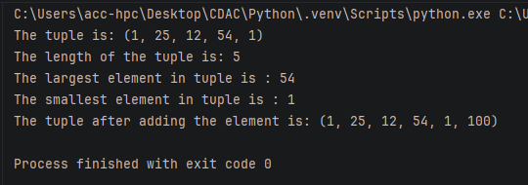

Write a program to:
1. Count vowels in a string
2. Reverse the string
vowels="aeiouAEIOU"
count=0
text=input("Enter the text:")
for char in text:
if char in vowels:
count+=1
print("The number of vowels is:",count)

#reverse the string
print("The reverse of string is :",text[::-1])

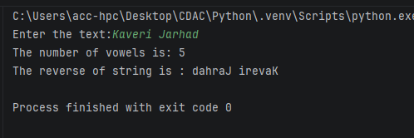

Check whether a string is a palindrome.
str=input("Enter the string:")
if str==str[::-1]:
print("The string is a palindrome.")
else:
print("The string is not a palindrome.")

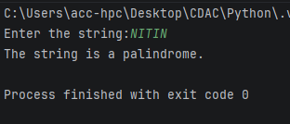

Create a dictionary of students and their marks. Display students scoring more than 75.
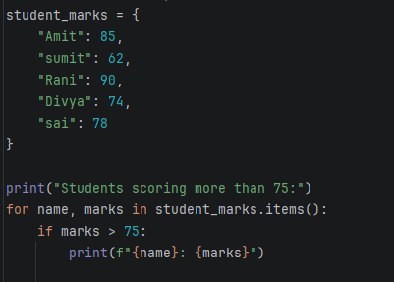
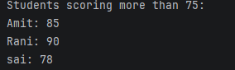

Add a new key-value pair and update an existing value.
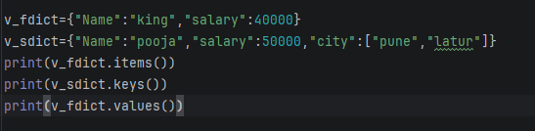
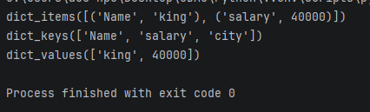

Create two sets and perform:
1. Union
2. Intersection
3. Difference
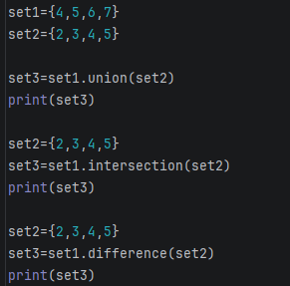
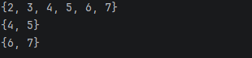

Write a program to remove common elements from two sets.
set1 = {1, 2, 3, 4, 5}
set2 = {4, 5, 6, 7, 8}

result_set = set1 ^ set2
print("Resulting Set:", result_set)

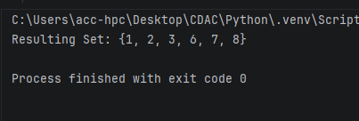

Write a program to find the second largest element in a list.
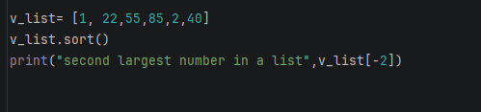
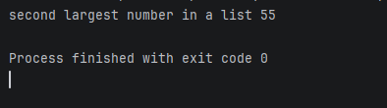

Write a program to split a list into even and odd numbers.
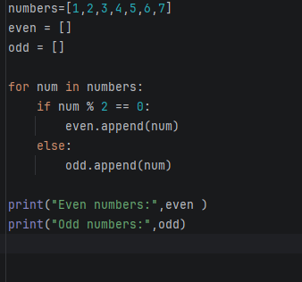
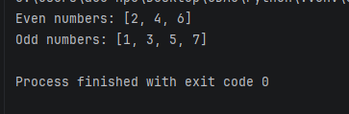

Write a program to merge two lists without duplicates.
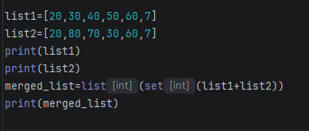
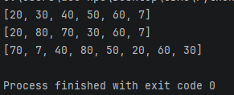

Find the index of an element in a tuple.
tup=(1,25,12,54,56,1)
print("index of an 56 in a tuple is:",tup.index(56))

